25.79: a)
b)
c)
d) Discharged at 10 A:
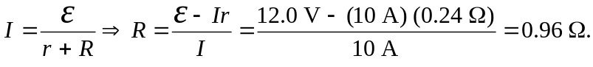
e)
f) Since the current through the internal resistance is the same as before, there is the same energy dissipated as in (c): 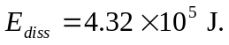
g) The energy originally supplied went into the battery and some was also lost over the internal resistance. So the stored energy was less than was needed to charge it. Then
when discharging, even more energy is lost over the internal resistance, and what is left is dissipated over the external resistor.

